Andrew Botsford
Andrew.botsford@inpex.co.jp
TMA01
B872 CREATING AND SUSTAINING VALUE

Contents
Part 1 2
Part 1 A 2
Part 1 B 3
Part 1 C 4
Part 2 6
Part 2 A 6
Part 2 B 7
2B i Return on sales 8
2B ii Asset utilisation ratio 8
2B iii ROCE 9
2B iv Current ratio 9
2B v Quick ratio 9
2B vi Gearing 10
2B vii Payables days 10
2B viii Receivables days 10
2B ix Inventory days 10
2B x Interest cover 11
Part 2C 11
Part 3 13
Attachments 16

Part 1

Part 1 A
Please refer to attached spreadsheet (Part A tab in Part1_Sheet_FINAL.xls) for calculations. The tables below show the difference between including (above) and removing (below) consumer services:
If consumer services were no longer offered, its contribution would fall from £360,000 to £0. It is assumed there would be no variable costs, and associated consumer fixed direct costs would fall from £180,000 to £0. It is assumed that apportioned fixed indirect costs (£275,000) would need to be covered by the other activities which would lead to a whole group Operating Profit decline from £278,000 to £98,000, a decrease in operating profit of £180,000.
The calculation above assumes that fixed costs remain the same and are redistributed among the remaining sectors. In reality there may be fixed cost savings available associated with reduced energy consumption and lower rent, for example.

Part 1 B
The attached sheet (Part B tab in Part1_Sheet_FINAL.xls) shows the calculations included in the analysis table below:
The organisation should consider how it apportions fixed indirect costs. In the accounts presented 26.7% of these were allocated to Consumer Services, resulting in an operating loss of £95,000 and Return on Sales (ROS) of -11.9% for that sector. It isn’t obvious how the apportioned fixed indirect costs applied have been allocated across the three sectors. The table above shows the percentage of total for each item (ie number of hours, revenue etc), and none of these match the allocation of apportioned fixed indirect costs.
Based on the available data, apportioning fixed indirect costs based on % of total contribution might be considered reasonable. In this case Consumer Services would be apportioned 17.31% of fixed indirect costs, resulting in a unit operating profit of £1,560 and return on sales of 0.19%. In this situation Consumer Services would breakeven.
On the other hand, apportioning fixed indirect costs based on % of hours worked might be reasonable if fixed costs are related to rent, energy bills etc. It may be worthwhile for the organisation to consider what these fixed costs are in more detail. The reported unit variable costs and specific fixed direct costs suggest there are cost differences between sectors, it is assumed these are due to differences in the costs of staff able to undertake work (and perhaps some specialist equipment and services needed) in these sectors and may not be linked to fixed costs. If apportioned fixed indirect costs were apportioned based on number of hours, consumer services would be apportioned 32.26% of fixed indirect costs, resulting in an operating loss of £152,260 and return on sales of -19.03%.
Additional factors to consider before deciding whether to cease offering consumer services to clients include whether the exposure provided by offering consumer services creates potential for brand growth through exposure and whether the service is beneficial for employee development. For example, it could provide valuable experience to work on for new employees. The organisation should also consider whether this year’s accounts are typical of most years or an outlier as it is important to prevent knee jerk reactions based on a single report.

Part 1 C
Please refer to attached spreadsheet (Part C tab in Part1_Sheet_FINAL.xls) for calculations. The tables below show the impact of reducing the fee to consumers by 25% (ie from £200 to £150) and increasing the number of hours to 5,000.
If the fee per hour is reduced by 25% from £200 the new fee will be £150, and if this were to result in a 25% increase in volume consumer hours would increase from 4,000 to 5,000. This change would result in a decrease in revenue of £50,000 pa (£800k-£750k) and an increase in variable direct costs of £110,000 pa (£550k-£440k), giving a decrease in contribution of £160,000 from Consumer Services. The manager’s conclusion is incorrect. If the promotion were to be applied the whole group would suffer a decrease in operating profit of £160,000 (assuming there is no influence on sales in the other service categories) so the promotion should not go ahead. This calculation also assumes apportioned fixed indirect costs are kept as they were originally allocated.
Break even analysis
The graph below shows Break Even Points (BEPs) in terms of hours provided for Consumer Services. A 25% fee reduction would take 11,375 hours to breakeven compared with the 5,056 hours required with no adjustment (ie keeping the fee at £200). Alternatively, increasing the hourly fee by 25% would result in a break even point after 3,250 hours. Before increasing the fee, the anticipated reduction in customers and knock on effects such as market loss and brand exposure should be considered.
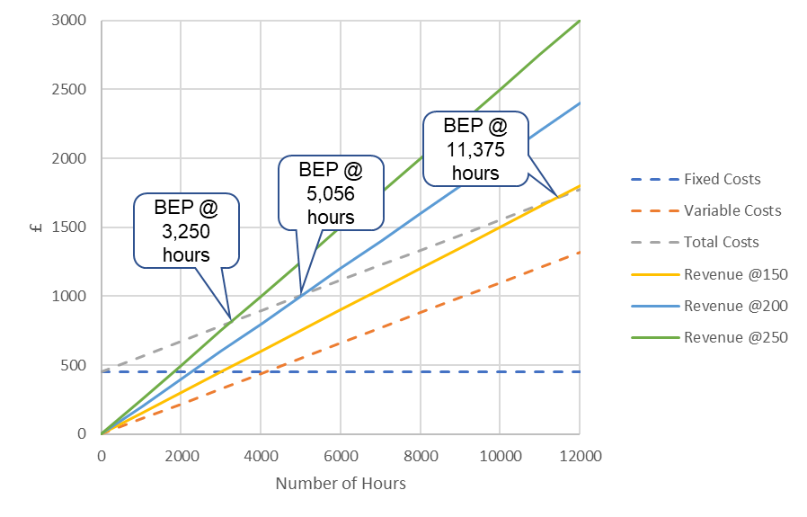

Part 2

Part 2 A
Devro Plc was established in 1991 following a management buyout of the edible collagen casing part of Johnson & Johnson (J&J). Collagen casings were pioneered by J&J in the 1950s. Devro listed on the London stock exchange in 1993 (Devro, 2023).
Devro’s main business is the supply artificial collagen casings and gels which are used by customers to produce meat products, in particular sausages. The collagen is taken from the hides of animals. Traditionally, sausages are manufactured from natural casings obtained mainly from sheep and pigs but also from other animals. Large scale sausage producers find it much easier and cost effective to use artificial casings instead of natural ones, and there are several other practical advantages in their usage instead of traditional casings (Zając, Pająk and Skowrya 2021).
Devro reported revenues of £252.4m and operating profit of £42.7m in 2021 (Devro, 2021). Revenues have remained consistent over the last 5 years within a range of £247.6m to £256.9m, operating profits over the same period have fluctuated more erratically ranging from a loss of £14m in 2019 to a maximum profit of £42.7m in 2021. Devro report a steadier underlying operating profit from 2017-2021 with consistent annual growth from £38.1m in 2017 to £42m in 2021. “Underlying operating profit” is an alternative performance measure used by Devro’s management and removes exceptional items. The organisation closed its site in Bellshill, North Lanarkshire, Scotland, which resulted in costs the management have defined as exceptional and therefore removed them from the underlying operating profit (Devro, 2020).
Devro have six manufacturing plants and five sales offices across the US, Europe, Asia, and Oceania. On December 31st 2021 there were 1,895 employees (62% male, 38% female). Over 100 employees work in customer facing operations such as sales and technical advisors. The organisation attempts to appeal to investors by highlighting its market leading position, global capacity, management team, attractive dividend, cash generation capability, and its long-term growth potential.
The organisation has identified three drivers of growth, the underlying market, the collagen market, and the Devro market share. The underlying market growth is linked to increased sausage consumption due to increased population, GDP per capita, urbanisation and food trends. The collagen market growth is linked to cost savings, consistency, and limited by labour shortages. The Devro market share growth is based on customer intimacy, product performance, and cost savings.
Two identifiable operating segments outline in their annual report are emerging markets and mature markets. Emerging markets include Latin America, Russia & East, Middle East & Africa, South East Asia and China. Mature markets include North America, Continental EU, UK & Ireland, Japan and Australia & New Zealand. The mature markets provided £179m (71%) of revenue in 2021, emerging markets provided £73.4m (29%) in the same period.
The underlying business model is based on selling collagen products to food manufacturers and/or local distributors. Devro differentiates itself from competitors by working with customers to develop new products that enhance efficiency and streamline workflows. They add value to investors by providing a consistent dividend, to customers by innovating products to increase appeal, to suppliers by long term reliable relationships, and to communities by providing attractive employment opportunities and reducing their environmental impact.
On December 31st, 2021, the organisation reported total assets valued at £336.8m down from £345.3m in 2020. This is linked to a decrease in property, plant and equipment. The total liabilities in 2021 were reported as £211.6m down from £246.3m in 2020. The decrease in liabilities is linked to decrease in debt and pension obligations. The changes highlighted above resulted in a reported increase in net assets from £99m in 2020 to £125.2m in 2021.
Cash generated from operations in the year to December 31st, 2021, is reported as £62.9m, up from £51.6m in 2020. The company paid dividends of £15m in 2021 and £10.5m in 2020.
References
Devro plc (2020) Annual report 2020. Available at: https://www.devro.com/media/1430/35958_devro_ar2020.pdf (Accessed: 23
November 2023)
Devro plc (2021) Annual report 2021. Available at: https://www.devro.com/media/1580/devro-ar21-full-aw-web.pdf (Accessed: 23
November 2023)
Devro plc (2023) History. Available at: https://www.devro.com/about/history/ (Accessed: 23 November 2023)
Zając, M. Pająk, P. and Skowyra, G. (2021) “Characterization of edible collagen casings in comparison with the ovine casing and their effect on sausage quality”, Journal of the science of food and agriculture, 2021, Vol.101 (14), p.6001-6009.

Part 2 B
Please see attached Excel sheet for full working (Part2_Sheet_FINAL.xls). The table below presents a summary of the ratios and some initial comments.

2B i Return on sales
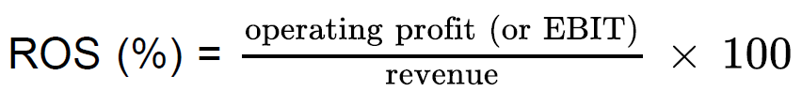

2B ii Asset utilisation ratio
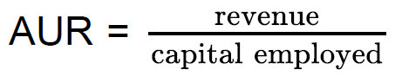

2B iii ROCE


2B iv Current ratio
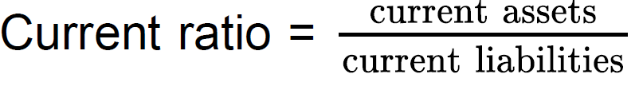

2B v Quick ratio
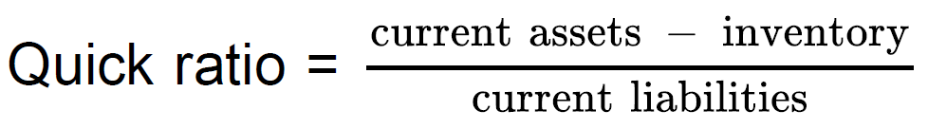

2B vi Gearing
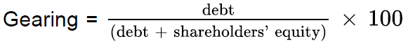

2B vii Payables days
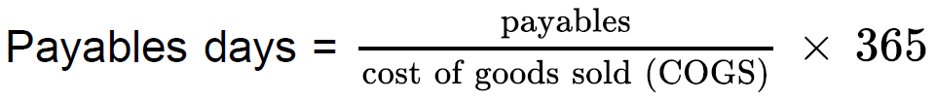

2B viii Receivables days


2B ix Inventory days


2B x Interest cover
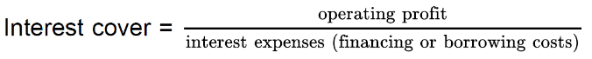

Part 2C
The ratios can generally be grouped into profitability, efficiency, and investor ratios. The main three ratios that I have picked to give the widest range of insights across each group are ROCE, Gearing and Payables Days.
- The ROCE ratio provides insights into profitability linked to debt, equity and revenues by incorporating ROS (which increased) and AUR (which didn’t vary much). ROCE increased from 2020 to 2021 primarily due to the increase in operating profit, which was enabled through maintaining costs and revenues increasing. Profitability is important for any commercial business, and the ROCE ratio helps to understand how Devro use their assets to increase value to shareholders.
- Gearing gives insights on top of the ROCE ratio in that it shows where capital was derived. If too much was provided by debt then business viability could be threatened if debts are called in, or if more borrowing is ever needed to meet unexpected costs. Gearing provides a longer term outlook on business viability in comparison with the quick ratio which focusses on near term activities. In comparing Devro’s gearing from 2020 to 2021 the increase in capital derived from equity and reduction in debt should present a healthy picture to external investors in terms of long term solvency and credibility. Debt was reduced following a repayment in the US accompanied by a decline in total assets.
- Payables Days increased by a large margin from 2020 to 2021 suggesting an increased time taken to pay suppliers, but it should be considered whether the payables figure in the balance sheet (at 31/12/2021) represents the normal situation through entire year. There were more payables outstanding in 2021 due to an increase in payables and decrease in cost of sales. The decrease in cost of sales is also reflected in the profitability ratios and may reflect good management of funds but may also be linked to increased burden on staff.
The ROCE ratio shows good profitability and Gearing suggests long term financial stability and potential to fund growth, which together presents a positive outlook for the business. Payables days have increased which means capital is retained within the business for longer, but this could have a detrimental impact on suppliers. The increased time taken to settle bills could also reflect an increased administrative burden on staff which links to cost control that enabled the increase in profitability. Cost controls on staff wages may provide short term profitability increase but care should be taken to ensure staff are sufficiently rewarded to prevent excessive staff turnover and any associated impact on operations in future.
Further information is requried to understand whether revenues increased due to external market conditions or increased market share. Devro have identified market growth potential (increased sausage consumption) which makes security of suppliers essential to maintain market share. I would therefore recommend investments to build and maintain good relationships with suppliers, and making sure payments are made within agreed timeframes.
Low gearing should make new borrowing easier for any new growth opportunities, but effort should be made to ensure current liabilities are not increased too dramatically in any new loans as the Quick Ratio was close to 1 in 2020 (reflecting a higher risk of insolvency).

Part 3
They may be finding it difficult because there is a lot of information in unstandardised form, although in general the key statements are required to be relatively standardised by following guidance from IFRS Accounting Standards or by following other regulatory standards. For example, different reports use terms such as “statement of financial position” and “balance sheet” to mean the same thing. In the case of Devro’s report (Devro, 2021) they use the term “statement of financial position” but still refer to the phrase “balance sheet” in some of the text. Centrica Plc (Centrica, 2022) use the term “balance sheet” for an equivalent item in their annual report. This is one example of how company reporting can vary. Wording, formats, and how financial information is presented are highly variable between company reports and sometimes seem to focus more on framing a message rather than merely reporting data to enable stakeholders to understand the company’s financial performance and position in an efficient way. Familiarity with the variation in terms used can be gained through experience.
Although financial statements include a lot of supplementary material, managers will normally want to ensure that the financial statements do provide an accurate picture of their organisation’s financial position, and they are also usually audited and commented by an external party. A way to maintain consistency between reports and filter out any company spin is to focus on the three main financial statements introduced by B872 (Fenton-O'Creevy et al, 2023). These are the balance sheet, the income statement, and the cash flow statement. In addition, the statement of changes in equity may be required to link the figures between these documents. Each document presents financial information in a different way so the most significant depends on the reason for reviewing them. It is possible to present these documents in different ways to achieve different external short-term appearances, for example by moving amounts to various subcategories (perhaps attributing an outlier as an exceptional item). In the main information must be reported in a consistent manner and should provide good insights when viewed over a reasonable timeframe.
The balance sheet, also referred to as a statement of financial position, can be used to provide insights into the size (or financial value) of the organisation. Change in assets is key, as short-term income could be generated from selling assets but then the longer-term outlook for increasing value might be reduced. Assets are probably the best measure of value, but if assets have been transferred out as dividends a decline in assets may not indicate a decline in value as the organisation may have achieved some goodwill from its benefactors. Although this cannot be measured financially, long-term regular dividend paying companies benefit from a certain loyalty from investors who may feel their money is safe and will deliver satisfactory returns, even if company asset value has shown a decline.
The income statement, also referred to as a profit and loss account can be used to provide insights into whether an organisation is profitable. Revenue or income is critical to performance, where it is coming from is also very important. Large organisations sometimes report group income which can come from many smaller subdivided businesses, and these organisations often also generate income from financing activities. The bottom line of the income statement should provide a figure of profit or loss for the reporting period after all considerations such as operating costs and taxation. When this figure is considered with other reporting periods a trend can be extracted, changes in contribution from operations, financing and other factors should be checked if there are significant variations in profit observed over time.
The cashflow statement gives details of what the organisation has spent funds on and where it has received funds from. It doesn’t provide details of assets or liabilities so an organisations true long-term position may be very different than cashflow during a single period represents. For example, if an organisation has very high debt to equity and huge monthly payments offset by regular sale of assets (shown as income) this would lead to severe risk to the long-term viability of the organisation if it were unable to meet debt repayments and has fewer assets to cash in. On the other hand, low income may be linked to short term trends and the company may have low debt and high asset values. In this case the cashflow statement on its own will not provide insights to the position. If this hypothetical case existed it might be suggested that management could improve their asset utilisation ratio to improve cashflows, but a wider consideration of circumstances would need to be undertaken.
The three reports highlighted above can be linked to gather an understanding of financial movements over the year or reporting period under review. The cash held at the bottom of the cashflow statement should also be represented as an asset in the balance sheet, the change in net equity over the period (requiring two values in the balanced sheet) should reflect net profit (or loss) adjusted for any transactions with the company owners who may receive dividends or provide additional capital. Sometimes the changes in equity following transactions with shareholders are detailed in a separate table often referred to as statement of changes in equity. As the balance sheet provides the link between the three main reports it could be argued that the balance sheet is the key individual document to represent an organisation, but in isolation it is hard to tell whether any active management is ongoing at all. The other sheets provide more details on decisions made over the course of the year, for example whether debt was reduced or increased and whether any investment was made in equipment or materials over the reporting period.
To summarise, companies present financial reports with a whole host of additional information. By picking out the balance sheet, income statement, and cashflow statement and then aligning the figures between these tables an unbiased overview of the financial performance over the reporting period can be gained. It is useful to learn some of the vocabulary or alternative terms to enable more efficient use of the tables, however with practice this becomes more straightforward.
References
Centrica plc (2022) Financial statements 2022. Available at: https://www.centrica.com/media/wxxls5vu/centrica_ar22_financial-statements.pdf (Accessed: 6 December 2023)
Devro plc (2021) Annual report 2021. Available at: https://www.devro.com/media/1580/devro-ar21-full-aw-web.pdf (Accessed: 23 November 2023)
Fenton-O'Creevy, M., Amor,.K., Claes, B., Knell, L., Tahera, K., Baralou, E., Bloom, P., Ponte, B., Samiotis, K., & Unnamed other (2023) 'B872 Reader'. B872: Creating and Sustaining Value. The Open University. Unpublished.

Attachments

- Part1_Sheet_FINAL.xls
File contains four tabs related to each part of Part 1.
- Part2_Sheet_FINAL.xls
File contains two tabs, the first showing ratio calculations and where input figures were derived and assumptions made, the second tab is a summary table of the ratios.

